Studying the variation in brightness of the lunar phases

The Science Inspired website has very nice exercise on this topic here
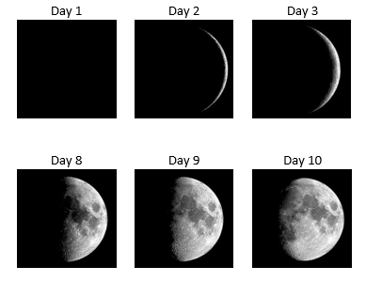
goo.gl/zeXgOY . Students are asked to estimate the brightness of the moon using photographs of the phases, enter the estimates into a spreadsheet and graph the result. Invariable something resembling a sine curve appears.

The next question is “is the variation really sinusoidal?”. The easiest way to find out is to use a mathematical model. This involves finding a formula for the area of the moon at any phase and then graphing it as it varies over a period of one month.

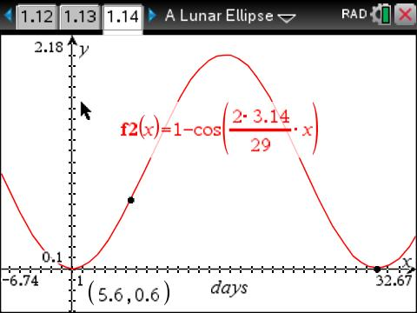
Students consider the question "What is the shape of the curve forming the terminator of the crescent moon?" They then calculate the area of the crescent and graph its variation over one month.
Probably the most difficult part of the exercise is working out that the angle the moon turns through each day of the month is 2πt/29 where t is the number of days elapsed and 29 is the approximate length of the month in days.
Use the tns file titled A Lunar Ellipse. (Pun intended)
Ian Galloway Copernican Revolutions www.cpd-physics.com

